INSTRUCTIONS

All text that has been highlighted in gray is guidance and should be replaced with your text. Everything not in gray is a heading and should remain. Please delete all instructions (including this one) before submitting.

# Executive Summary

**Organization Overview**

Before we get to the analysis of the solution please insert here a brief description of your organization and include a website link. Word limit 250 words.

**Effectiveness**

| **Solution Name** |  |
| --- | --- |
| **Brief Description** | In 250 words:   * What does the solution do? * How does the solution reduce emissions? * Provide an overview of the steps the solution takes to reduce emissions. |
| **Emission Reduction Potential** | In 450 words:  Summarize your effectiveness calculations against Aii baselines, referencing the performance data used to calculate those savings. These performance data points should be taken from the analysis included in the Comparative Study section. |

**Reach**

| Solution Potential | In 300 words:  Describe where the solution performs best, please use data where appropriate. |
| --- | --- |
| Ease of implementation | In 200 words:   * Describe how easy the solution is for facilities to implement. Is it plug and play? If not, does the staff require specific training? * How much space does the machine take up? * Do any other process modifications need to take place? |
| Drawbacks & Limitations (if any)  Failure to disclose drawbacks and limitations may lead to delisting in the future. | In 300 words:  List if there are any drawbacks or limitations to the solution that would impact its effectiveness and reach (for example, it doesn't work on certain shades, needs lots of floor space, requires training for staff to manage properly, slows down a process, etc.) |
| Competitive Landscape | List any solutions offering similar technologies/processes to the applying solution. |

**Scalability**

| Commercial Viability | What are the up-front and ongoing costs to run?  What is the payback period?  How does this cost compare with existing solutions? |
| --- | --- |
| Market Share | What is the current market share?  How many facilities, brands, countries? |
| Partnership | Please list all partnerships. |

# Methodology of Comparative Study

In this section of the report, the applicant should clearly explain how its performance data was collected, how it compares to the Ready Reckoner’s baseline, and identify the comparison the applicant has chosen as the base case. The base case may be the market-dominant technology or a facility with a before and after.

This section should also clearly and in detail describe how exactly the solution works and reduces emissions.

Please note we do not necessarily expect a new trial to take place for this application. Past assessments can be used, but they must be formatted according to the structure outlined in this document. If submitting a past trial, please state the year the trial took place.

In addition to methodology, key information to include:

* Year of trial
* Country
* Facility type & size
* Volume of production tested

# Comparative Study

Please describe who conducted the study (in-house, independent consultancy etc.), in what facility, and under what conditions.

Table 1 should demonstrate the technologies/processes against which your technology is compared in the market. Please note, that it may be multiple technologies/processes or just one, depending on your solution. Please fill out as many rows as needed.

*Table 1: Comparison - Conventional vs Registrant technology*

| **Conventional technology process** | **Registrant technology**  **process** | **Name of corresponding Model Process from Ready Reckoner** |
| --- | --- | --- |
|  |  |  |
|  |  |  |
|  |  |  |

Please provide a max. 400 word description of the conventional solution and how your solution differs.

# Process Flow

**Applicant Solution Process Flow & Process Steps**

Please demonstrate the process flow of your solution with a diagram. Where relevant, please extend this beyond your solution if your solution interacts with other processes in the facility.

Where there is a significant change to a process, such as combining or eliminating processes or sub-processes that you would find in a typical industry manufacturing process, please illustrate these changes with a flow diagram.

Examples are given below.

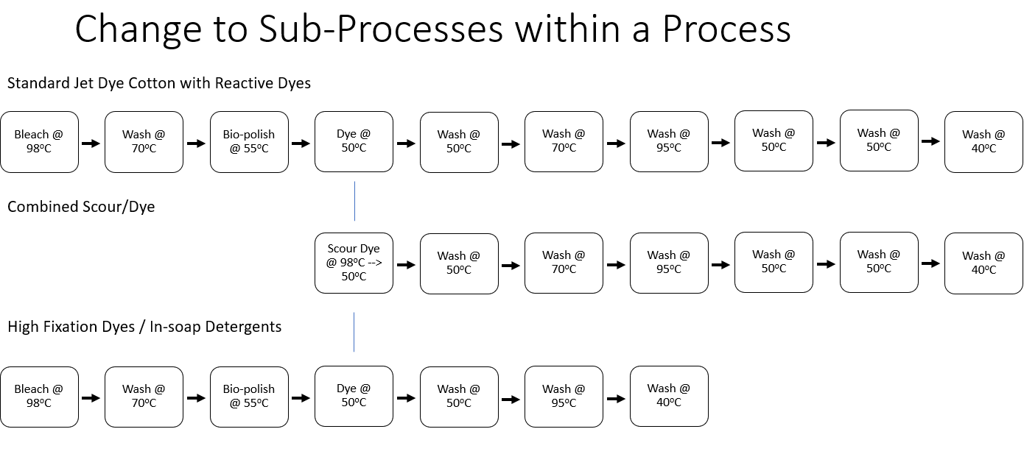

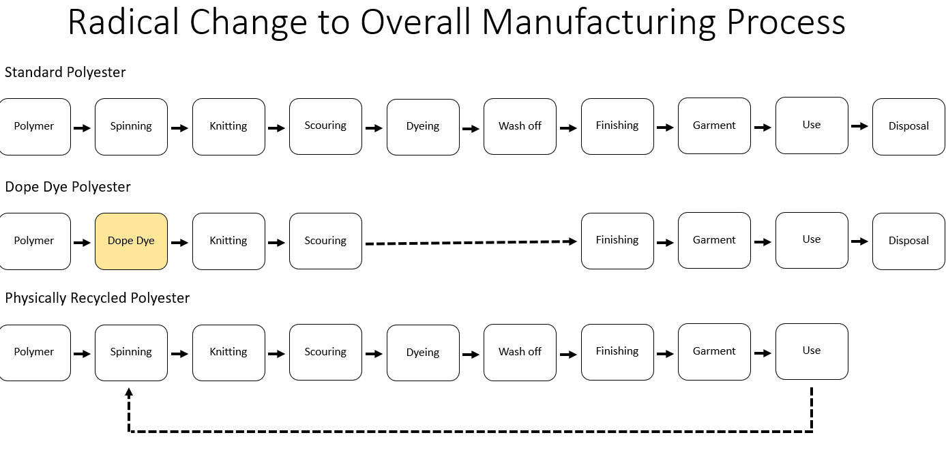

Please list and describe the different steps in the process (for example: how many baths, at what temperature).

Please also describe your solution’s process flow in response to the following prompts:

* time of implementation vs conventional
* other resource/energy use vs conventional

**Conventional Solution Process Flow & Process Steps**

Please also provide a process flow and summary of the conventional, current market baseline procedure.

# Observations & Results

**Technology:**   
Please provide a one-page overview of how the technology works to save emissions. This should match the process flow above and clearly explain each step the solution operates in and how emissions savings are achieved.

**Reported Savings:** Please summarize the savings against conventional technologies and provide a summary of the calculations in a table for this section. Please remember to include not only the real baseline from the facility you measured this against, but also the kwh/kg and CO2e/kg according to the Model Processes in the Ready Reckoner provided in the application.

**Concerns Addressed**: Please describe any concerns around your product that have been addressed through scaled implementation.

# Product Quality & Ease of Implementation

Please describe in one page how your solution maintains product quality and how easy it is for the facility to implement.

Testimonials from facilities are greatly appreciated.

# APPENDIX I – CASE STUDIES & TESTIMONIALS

Please include 2-5 case studies or testimonials from facilities that have implemented your solution. These case studies/testimonials should include data that addresses the solutions’ effectiveness at that facility. Additionally, the testimonials should describe the ease of working with the solution, its impact on product quality, etc. Please name the referenced facilities and attribute quotes to individuals where possible.

These case studies/testimonials should substantiate the claims made above in the body of the report.

# APPENDIX II – PICTURES

Please submit pictures of the solution in use onsite. These do not necessarily have to correspond with the case studies & testimonials above.